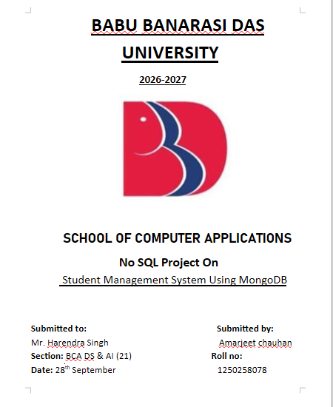
PROJECT OVERVIEW

PROJECT OBJECTIVES
• To create a library database and organize data into collections.
• To insert 50 book records and supporting student and transaction records.
• To perform Create, Read, Update, and Delete (CRUD) operations.
• To use comparison operators such as $gt, $lt, $gte, and $lte.
• To use logical operators such as $and, $or, and $in.
• To perform sorting, limiting, filtering, and projection.
• To use aggregation for category-wise count, average price, and total library value.

1. CREATE / SWITCH DATABASE
use LIBRARYDB
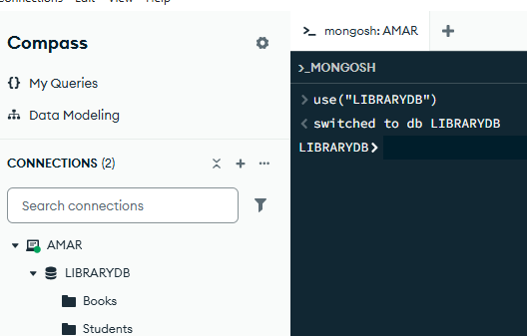
Figure: LIBRARYDB database selected successfully in MongoDB Compass.
Explanation: Creates the LIBRARYDB database if it does not already exist, or switches to it if it exists.

2. CREATE COLLECTIONS
Figure: LIBRARYDB collections visible in MongoDB Compass.
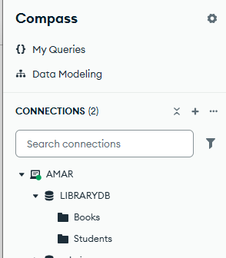
Explanation: Creates the three collections used in the Library Management System.

3. INSERT 50 BOOK RECORDS
Explanation: Inserts 50 book documents into the Books collection. Each document stores bookId, title, author, category, price, and availability.
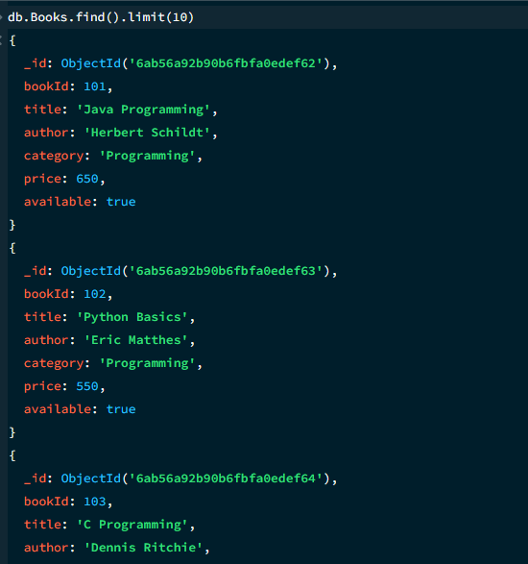
Figure: Sample records from the 50-book Books collection.

4. INSERT 20 STUDENT RECORDS
Explanation: Inserts 20 student/member documents into the Students collection.
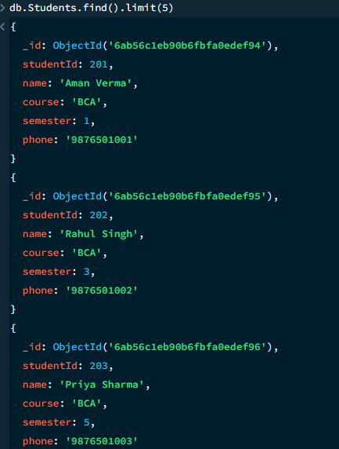
Figure: First five documents from the Students collection.

5. INSERT TRANSACTION RECORDS
Explanation: Stores book issue and return records. The transaction documents connect studentId and bookId with issue date, due date, return date, and status.
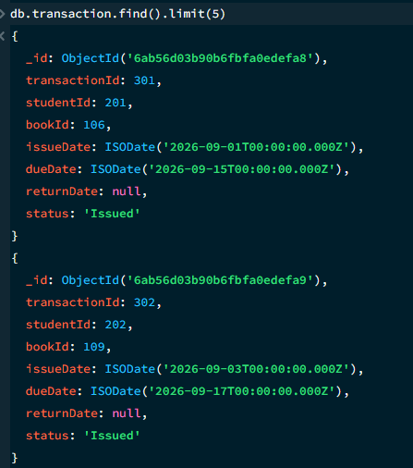
Figure: First five documents from the transaction collection.

6. DISPLAY BOOK RECORDS
Explanation: Retrieves documents from the Books collection.
Figure: Display of book records from the Books collection.

7. LIMIT OPERATION
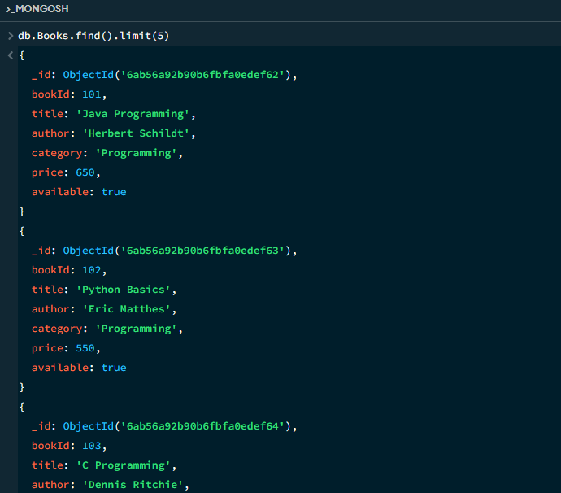
Figure: First five documents from the Books collection.
Explanation: Displays only the first five book documents.

8. SEARCH BOOK BY ID
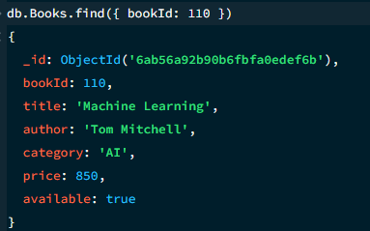
Figure: Book search using bookId 110.
Explanation: Finds the book whose bookId is 110.

9. SEARCH BY CATEGORY
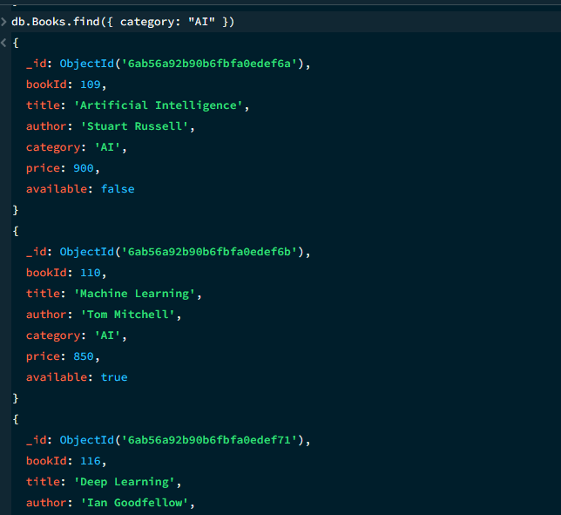
Figure: Books belonging to the AI category.
Explanation: Finds all books in the AI category.

10. AVAILABLE BOOKS
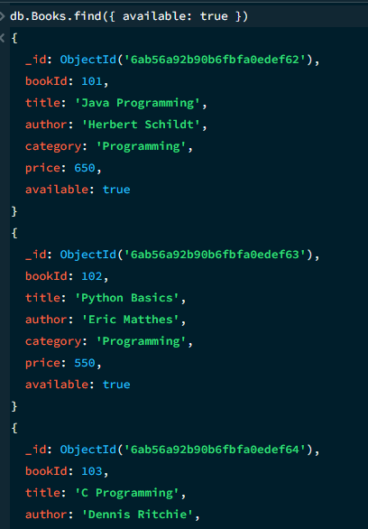
Figure: Available books in the library.
Explanation: Displays books that are currently available.

11. GREATER THAN — $gt
Figure: Books with price greater than 800.
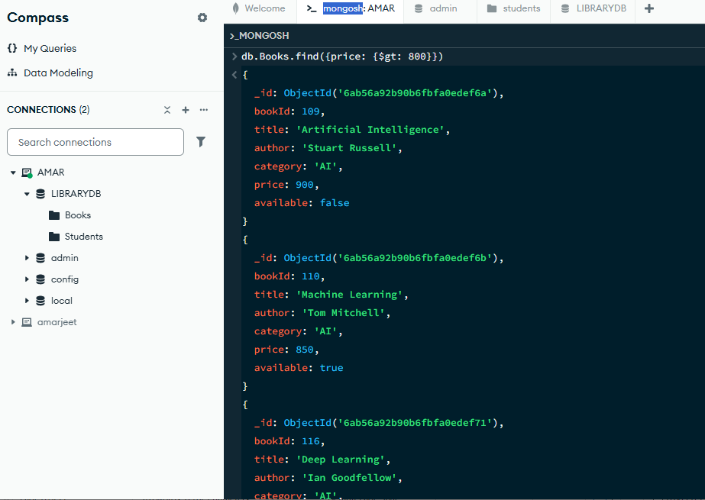
Explanation: Finds books with a price greater than 800.

12. LESS THAN — $lt
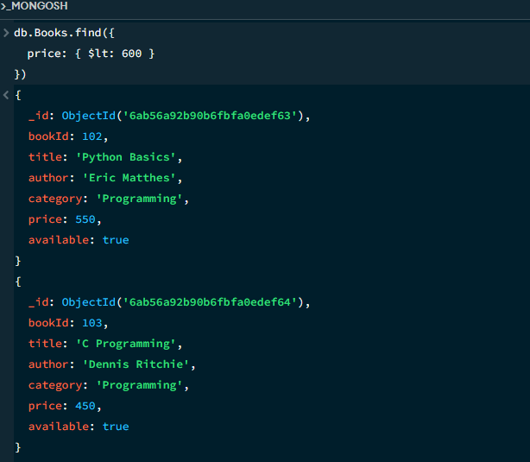
Figure: Books with price less than 600.
Explanation: Finds books with a price less than 600.

13. RANGE — $gte AND $lte
Figure: Books in the price range 600 to 800.
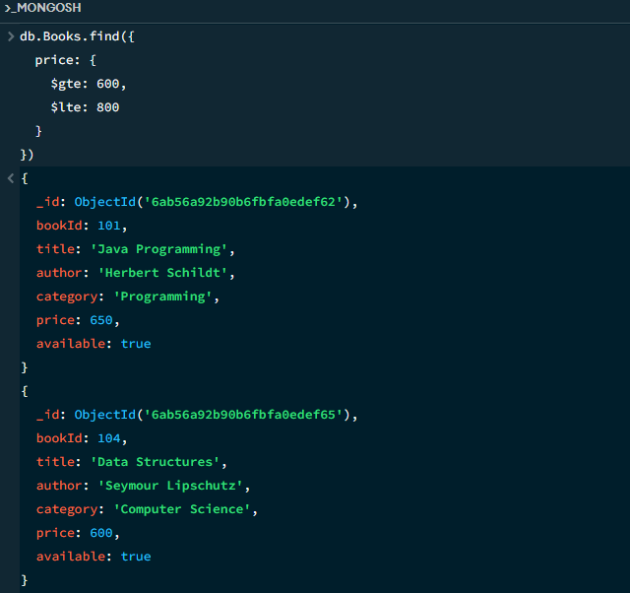
Explanation: Finds books priced from 600 to 800, inclusive.

14. AND OPERATION — $and
Figure: Logical AND query for available AI books.
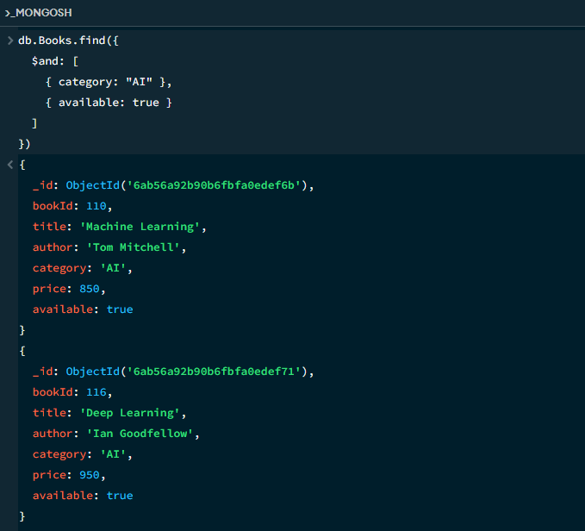
Explanation: Finds books that are in the AI category and are also available.

15. OR OPERATION — $or
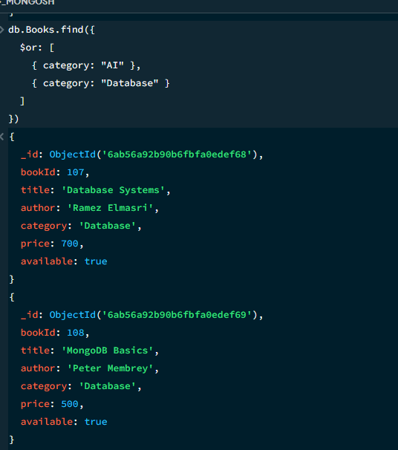
Figure: Logical OR query for AI or Database books.
Explanation: Finds books whose category is either AI or Database.

16. IN OPERATION — $in
Figure: $in query for selected book categories.
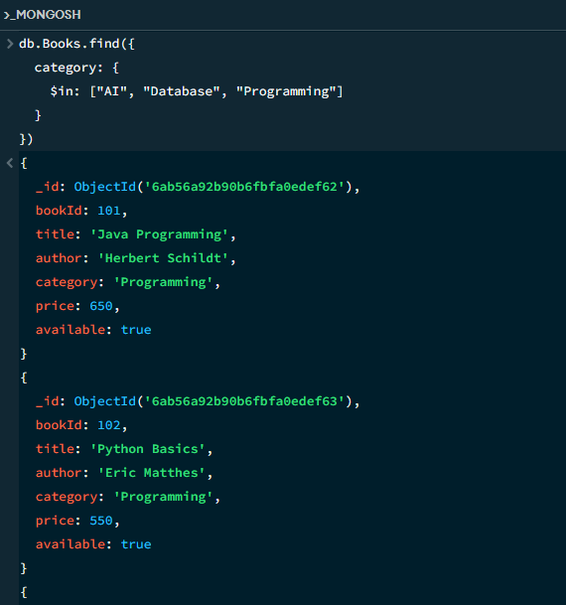
Explanation: Finds books belonging to any of the listed categories.

17. SORT ASCENDING
Explanation: Sorts books from lowest price to highest price.
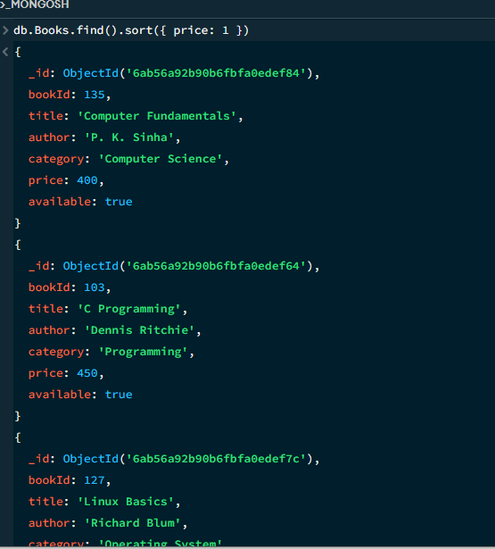
Figure: Books sorted by price in ascending order.

18. SORT DESCENDING + LIMIT
Figure: Top five most expensive books using sorting and limit.
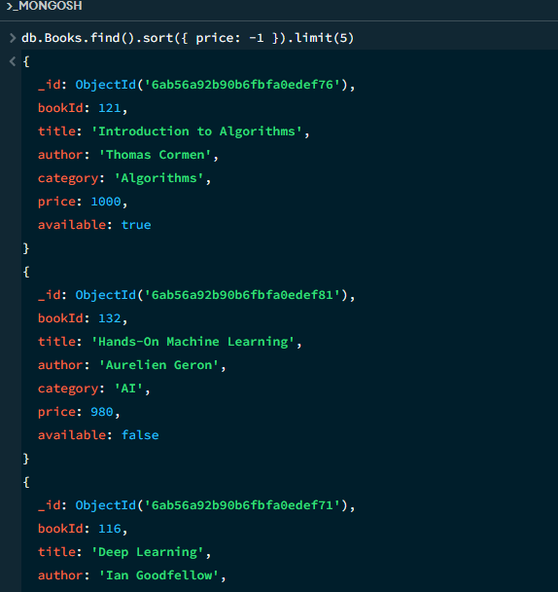
Explanation: Displays the five most expensive books.

19. PROJECTION
Figure: Projection showing selected book fields.
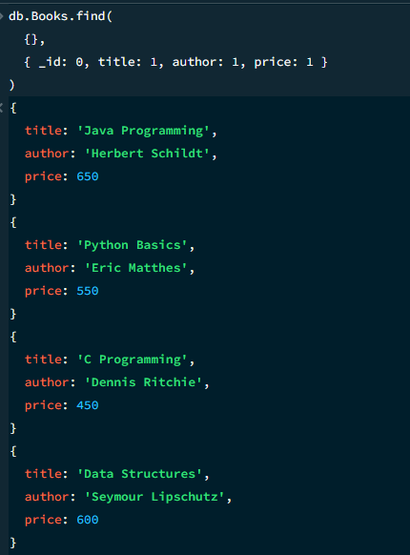
Explanation: Displays only title, author, and price while hiding the MongoDB _id field.

20. CREATE OPERATION — INSERT ONE
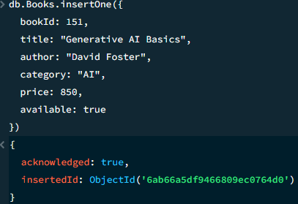
Figure: insertOne() successfully inserted the temporary CRUD test book.
Explanation: Adds one new book document to the Books collection.

21. UPDATE OPERATION
Figure: updateOne() successfully modified the book price.
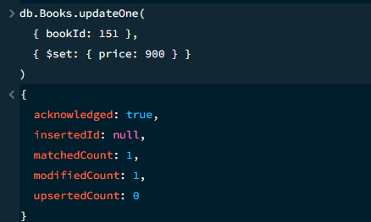
Explanation: Updates the price of bookId 151 to 900.

22. DELETE OPERATION
Figure: deleteOne() successfully deleted one document.
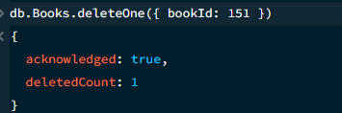
Explanation: Deletes the temporary book with bookId 151. After this operation, the Books collection returns to 50 records.

23. COUNT DOCUMENTS
Figure: Total number of documents in the Books collection.
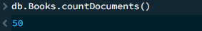
Explanation: Counts the documents currently present in the Books collection. After the temporary CRUD example is deleted, the expected count is 50.

24. AGGREGATION — CATEGORY-WISE BOOK COUNT
Figure: Category-wise book count using aggregation.
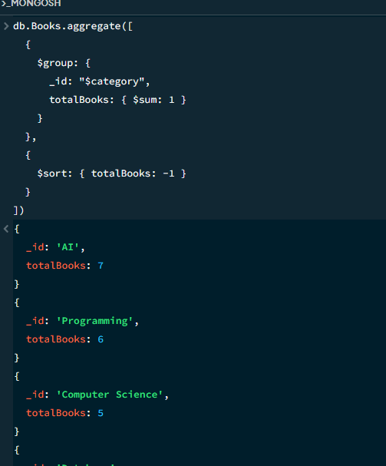
Explanation: Groups books by category, counts books in each category, and sorts the category counts from highest to lowest.

25. AGGREGATION — AVERAGE PRICE BY CATEGORY
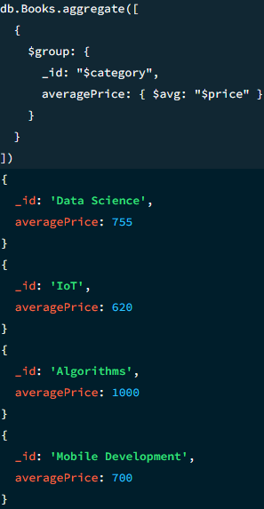
Figure: Category-wise average book price using aggregation.
Explanation: Calculates the average book price for each category.

26. AGGREGATION — TOTAL LIBRARY BOOK VALUE
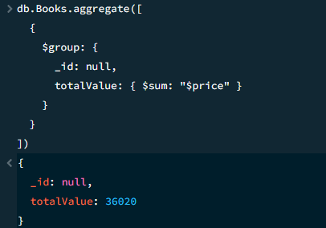
Figure: Total library book value using aggregation.
Explanation: Calculates the sum of the prices of all books in the Books collection.

27. AGGREGATION — AVAILABLE VS UNAVAILABLE
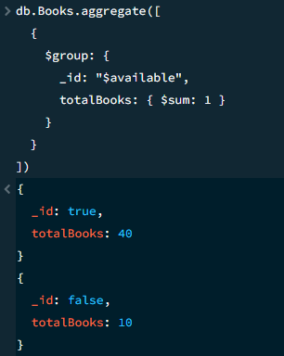
Figure: Available versus unavailable book count.
Explanation: Groups books by availability and counts available and unavailable books.

MONGODB OPERATORS AND METHODS USED
Operator / Method | Meaning | Example
$gt | Greater than | price: { $gt: 800 }
$lt | Less than | price: { $lt: 600 }
$gte | Greater than or equal to | price: { $gte: 600 }
$lte | Less than or equal to | price: { $lte: 800 }
$and | All conditions must be true | $and: [...]
$or | At least one condition is true | $or: [...]
$in | Matches any value in a list | $in: ["AI", "Database"]
$set | Updates selected field(s) | $set: { price: 900 }
$sum | Counts or totals values in aggregation | totalBooks: { $sum: 1 }
$avg | Calculates average in aggregation | averagePrice: { $avg: "$price" }
sort() | Sorts query results | sort({ price: -1 })
limit() | Limits returned documents | limit(5)
aggregate() | Performs data analysis pipeline | db.Books.aggregate([...])

DATABASE STRUCTURE
Database: LIBRARYDB
• Books — 50 documents containing bookId, title, author, category, price, and available.
• Students — 20 documents containing studentId, name, course, semester, and phone.
• transaction — 15 documents containing transactionId, studentId, bookId, issueDate, dueDate, returnDate, and status.

PROJECT OUTCOME
The screenshots in this report are actual MongoDB Compass/mongosh outputs captured during project execution.

PROJECT SUMMARY
Through this project, I learned how to insert, retrieve, update, and delete documents; filter and sort records; use operators such as $gt, $lt, $gte, $lte, $and, $or, and $in; select fields using projection; and analyze library data using aggregation operations such as $group, $sum, and $avg.
Overall, the project demonstrates how MongoDB can be used to organize and query library data efficiently.

